**General Background:**

In today's era, the demand for prior work experience at the early stages of a career presents a significant challenge for students and graduates in technological and scientific fields. Despite acquiring in-depth academic knowledge, many employers require a portfolio or hands-on experience with industry-standard tools that are often not covered in academic curricula. These requirements make it difficult for candidates without prior work experience to integrate into the job market.

At the same time, nonprofit organizations struggle to find innovative solutions to complex problems due to a lack of resources and professional manpower.

The proposed platform aims to bridge this gap by creating mutual connections between three main user groups:

* **Students & Junior Professionals** – The primary users of the platform, who gain hands-on experience in technological projects and build an impressive portfolio.
* **Mentors** – Experienced professionals who provide guidance, feedback, and career direction to junior participants.
* **Nonprofit Organizations** – Provide real-world projects, creating practical learning opportunities while solving significant technological challenges for the community.

### Value Creation Through Collaboration:

The collaboration between these groups generates shared value:

* **Juniors** receive practical training and essential skills for the job market.
* **Mentors** contribute their expertise while fostering the next generation of professionals.
* **Nonprofits** benefit from high-quality technological solutions that support their social missions.

Through this platform, a dynamic space is created that integrates professional development, social contribution, and essential skill-building such as teamwork, problem-solving, and task management. The platform aspires to provide equal opportunities for all users, regardless of their background, serving as a bridge between academia and the professional world.

**System Main components:**

1. The platform will be a web-based application with a mobile-friendly interface.
2. User Access & Authentication: The platform will support both guest browsing and registered user access
   1. Guest Browsing **-** Users will be able to access limited content without logging in. Guest users will have access to:

* Main platform screen – A general overview of the platform, including its purpose, features, and how users can participate.
* View open projects awaiting team members – Guests can browse projects that are actively seeking participants, including access to the full project page.
* If a guest user clicks on "Request to Join", a registration/login prompt will appear.
* View completed project pages – If a user shares a project on a social network or external platform, guests will be able to access its public project page without registration.
  1. User Authentication - Users will log in using the email and password they registered with.
  2. User Registration - Users will have two options to sign up:
     + Sign up with an existing Gmail account.
     + Manual registration by providing:
* Email address
* Password
* First and last name
* Profile picture

1. Interface Language: The platform's default and primary interface language will be English.
   1. All UI elements, buttons, notifications, and system messages will be displayed in English.
   2. Future versions may support additional languages based on user demand.
2. User experience & design requirements:
   1. The platform should have a user-friendly interface, similar to modern social media platforms.
   2. Navigation should be simple and intuitive, making it easy for users to get started and engage with the platform.
   3. The design should be modern and visually appealing, targeting a young and tech-savvy audience.
   4. The interface should have a clean layout, smooth interactions, and a responsive design that enhances the overall experience.
   5. The platform should be accessible to nonprofit organizations, considering that many of them may have limited technological expertise.
   6. Content and tools should be structured clearly, ensuring that non-tech users can easily access and utilize the relevant features.
3. The platform will categorize users into the following groups:   
   during the registration process, users will be required to specify their user type:

* Builders (General Users)
* Organizations (Nonprofit)
* Mentors

1. After completing the registration process, users will be directed to a profile setup screen tailored to their selected category:
   1. Builder**:** Users will define their personal profile, including:

* Education status (Student/Junior/Bootcamp Graduate)
* Programming languages
* Technologies
* Preferred field (Backend/Frontend/Fullstack…)
* Areas of interest
  1. Mentor**:** Users will define their personal profile, including:
* Education status
* Programming languages
* Technologies
* Area of expertise (Backend/Frontend/Fullstack…)
* Areas of interest
  1. Organization: Organizations will provide:
* Organization name
* Field of activity and the community they serve
* Website/social media links (if available)

1. For each user, the system will store the following information:

* User type
* Profile details provided during the profile setup
* For Builders and Mentors: Completed projects
* For Nonprofit Organizations: Opened projects and the users who participated in them
* For Builders and Mentors: Users and organizations they have collaborated with in previous projects
* All posts and comments published by the user

1. Profile view screen: The personal profile will allow each user to present and view their professional information in a clear and impressive manner. The screen will include the following details:
   1. Profile Details- The user's profile picture will be displayed prominently at the top of the page, along with their full name, user type (general user, mentor, or nonprofit), and a professional status or a short descriptive tagline.
   2. Achievements section- A visual representation of the achievements the user has earned on the platform (e.g., completed projects, contributions to forums, work on nonprofit projects). Achievements will be displayed in a graphical format, such as badges or trophies.
   3. Projects section- A list of projects the user has participated in.The project will be clickable, leading to a dedicated project details page (see section 9 for more details). Each project will be displayed as a short information card containing:

* Project name
* Programming languages
* key technologies used
* The user’s role in the project
* Project status: Open, In Progress, Completed
  1. Expertise section- A list of skills and tools the user is proficient in. The information will be derived from the profile setup, including:
* Programming languages learned
* Technologies the user has experience with
* Professional interests (Frontend, Backend, Fullstack, etc.)

1. Project details page: The project will have a dedicated page displaying detailed information, including:
   1. Project name – The official name of the project.
   2. Project goal and description – A clear explanation of the project's purpose, what problem it aims to solve, and what was built.
   3. Nonprofit involvement – If the project was built for a nonprofit organization, a clickable link to the nonprofit’s profile, including a short description of the organization’s mission.
   4. Participants and roles – A list of all team members involved, displaying:

* Their full name and profile picture
* Their specific role in the project (e.g., Backend Developer, UX Designer)
* Clickable links to their profiles for further details
  1. Technologies and programming languages used – A structured list or visual representation of the tech stack, categorized by front-end, back-end, database, and additional tools used.
  2. Project status – The current state of the project: Open, In Progress, or Completed.
  3. Share the project on social media using a link to this screen and a text template.

### Project Creation and Configuration: users will have the ability to create new projects and define key parameters.

### Project Setup- When creating a new project, users will be required to configure the following settings:

* Difficulty level selection: Choose the complexity of the project.
* Estimated duration: Define the expected timeframe for completion (Day/Week/Month).
* Programming language: Select the primary programming language for project implementation.
* Development methodology: Choose a workflow approach (Agile, Scrum, Waterfall, Kanban) that will determine the scheduling of tasks.
* Project visibility: Define whether the project will be public (open for anyone to join) or private (restricted to pre-selected team members).
  1. Project Matching and Team Formation- Once a project is created, the platform will suggest relevant projects for execution based on:
* The user’s areas of interest selected during project creation.
* The specific configurations set during the project setup.
* The recommended number of developers needed.
* The roles required, such as: frontend Developer, backend Developer
  1. Allow the user to-
* Invite a mentor to provide guidance throughout the project.
* Launch the project in pending status, enabling more team members to join before active development begins.

1. Project Join Screen: The platform will include a Project Join screen, where general users and mentors can browse open projects and view details about the current team members. The screen will display two types of projects available for joining:
   1. Ongoing projects:

* Projects that have already started but have not yet filled all team positions.
* Projects where a team member left during development, requiring new collaborators.
  1. Pending projects:
* Projects that have not yet started and are waiting for additional team members to join.

1. Project Workflow: The project workflow on the platform will be divided into structured phases to ensure an organized, efficient process that aligns with the selected methodology.
   1. Project Guidance & Supervision-

* A human mentor or AI mentor will monitor team progress and ensure goals are met.
* Introductory and progress meetings will take place according to the schedule set during project creation.
  1. Task Management & Execution-
* Each participant will receive tasks based on their assigned responsibilities.
* Participants will be required to report progress on their tasks regularly.
  1. Collaboration & Documentation-
* Project files will be managed in GitHub for version control and collaboration.
* A System Design Document will be created and maintained to outline the project’s architecture and technical structure.

1. Project Management Tools: The platform will provide an integrated project management tool similar to Monday or Jira, allowing teams to efficiently organize and track their progress.
   1. Key Features-

* Task assignment and management – Team members will be able to assign and track tasks within the project.
* Task documentation and deadlines – Each task will include a description, assigned team member(s), and a defined execution timeline.
* Progress tracking – Each participant’s progress on tasks will be monitored through a status system (e.g., To Do, In Progress, Completed).

1. Professional Consultation Forum: The platform will feature a structured professional forum where general users and mentors can initiate and participate in focused discussions on technical topics. The forum will function as a Q&A space, allowing users to find direct solutions to technological challenges while engaging with a supportive community.
   1. Topic Categories - The forum will be organized into predefined categories, making it easy for users to find relevant discussions. Categories will include:

* Specific technologies (Frontend, Backend, DevOps, etc.)
* Programming languages
* Project planning and design challenges

#### Post Structure - Each post will be structured in a clear and organized manner:

* Main question – A concise and descriptive title summarizing the problem or challenge.
* Detailed description – Users can elaborate on their question, providing relevant technical details such as error messages, code snippets, contextual explanations
  1. Responses & Answers -
* Response ranking system – Users can upvote responses based on their effectiveness. Highly rated responses will appear at the top of the thread.
* Accepted answer feature – The original poster can mark the best response as an “accepted answer”, making it easier for others to find the most helpful solution.
  1. Personalized Notifications - Users will receive notifications for:
* New replies to their posts.
* Updates on threads they are following.
* A “bell” feature will allow users to subscribe to specific posts and receive real-time alerts when new responses are added.

1. Gamification – Trophy System: The platform will feature a trophy-based gamification system for both general users and mentors. Users will be able to complete specific tasks to earn trophies, encouraging engagement and rewarding contributions. This system can be expanded with additional challenges in the future.
   1. Trophies for General Users -
      * Ready to Work – Complete full profile setup.
      * First Steps – Complete the first project on the platform.
      * Team Player – Successfully complete a team project with other users.
      * Community Star – Complete a project for a nonprofit or charitable organization.
      * Reliable Partner – Receive 5 positive feedback ratings from other users for project contributions.
      * Master – Successfully complete 5 projects on the platform.
      * Social Circle – Connect with 50 friends on the platform.
      * Saved the Ship – Join an ongoing project and help complete it.
      * Golden Advisor – Provide 10 valuable tips in the professional consultation forum.
   2. Trophies for Mentors -
      * Ready to Work – Complete full profile setup.
      * Certified Guide – Successfully mentor a user or team through a project.
      * Bridge Builder – Successfully mentor 3 projects on the platform.
      * Experienced Mentor – Receive 10 positive feedback ratings from users for project guidance.
      * Social Contributor – Post 10 insightful tips for general users in the consultation forum.
      * Community Star – Mentor a project for a nonprofit or charitable organization.
      * Social Circle – Connect with 50 friends on the platform.
      * Steered the Ship – Guide an ongoing project that was already in progress.
2. User Feedback System: The platform will include an optional feedback feature at the end of each project, allowing users to leave short, open-ended comments about their teammates and mentors.
   1. Users can write a brief, free-form review about their experience working with a specific team member or mentor.
   2. Feedback can highlight positive contributions, teamwork, professionalism, or areas for improvement.
   3. Providing feedback is optional, and users can skip it if they prefer.
3. Smart Summary: General Overview: The platform will feature a Smart Summary tool that provides an a, available for both general users and mentors.
   1. How It Works -
      * The platform will use AI to analyze user feedback, completed projects, and overall engagement.
      * A concise, professional summary will be generated to highlight key achievements.
   2. Summary Content -
      * Core strengths – Identifying the user's standout skills and technical expertise.
      * Team contributions – Insights on teamwork, collaboration, and leadership.
      * Technical specializations – Highlighting key technologies and methodologies used in projects.
   3. User Benefits -
      * Users can add the summary to their profile as a professional highlight.
      * The summary can serve as a cumulative recommendation when applying for jobs.
      * The summary will update dynamically as users complete projects and receive new feedback, ensuring it reflects their latest progress.

**MVP Development Scope (To Be Completed by June):**

The initial development phase will focus on building the core functionality of the platform, ensuring it is operational and allows basic user interactions.

1. System Infrastructure:
   1. Database setup – Creating tables for users, projects, and registrations.
   2. Development environment – Setting up GitHub, a shared development environment and defining the system architecture.
   3. Basic homepage – Displays general information and navigates to different sections of the platform.
   4. User registration and authentication -

* Login via Gmail and/or manual registration with basic validation.
* Session/Auth management (keeping users logged in).

1. Basic Project Management:
   1. Project creation – A form for adding project details: name, description, technologies, status.
   2. Viewing open projects – A screen displaying available projects that users can join.
   3. Joining a project – A "Join" button that either sends a request to the project owner or directly adds the user (based on project settings).
   4. Basic project page – Displays project details such as name, description, technologies, and team members.
2. Profile Pages and User Management:
   1. Basic user profile – Displays profile picture, name, and user type: general user, mentor.
   2. Profile editing – Allows users to add skills, areas of interest, and professional status.
   3. Viewing other users' profiles – Displays basic information without revealing sensitive details.
3. Design:
   1. Interface & Navigation – Designing a clean, intuitive, and modern user experience.
   2. Design System – Establishing consistent styles, colors, and UI components.
   3. Wireframes & Prototypes – Creating initial layouts and interactive mockups.

**Screen demos:**

Main Page:

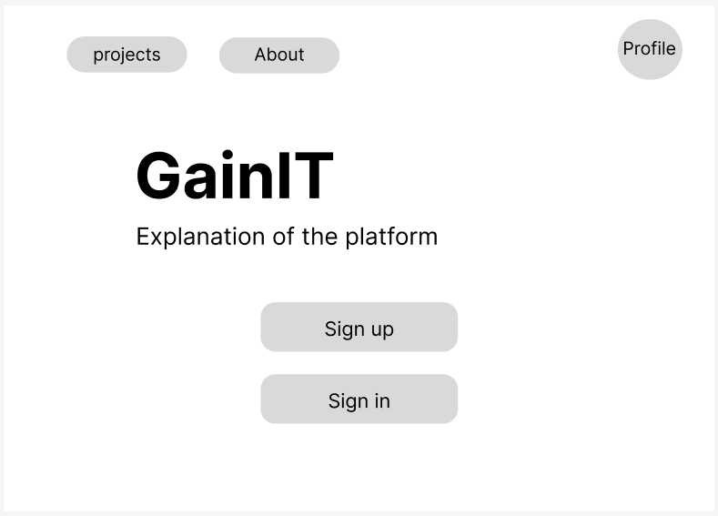

User Profile:

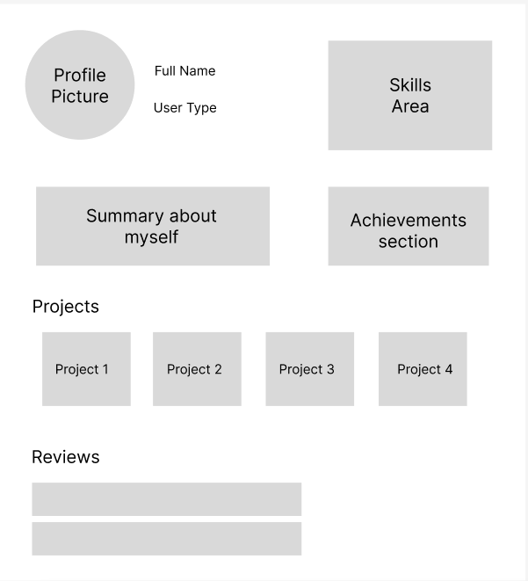

Project creation:

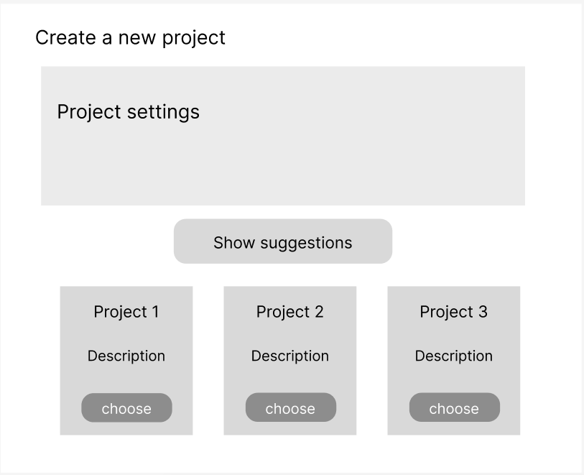

Search projects:

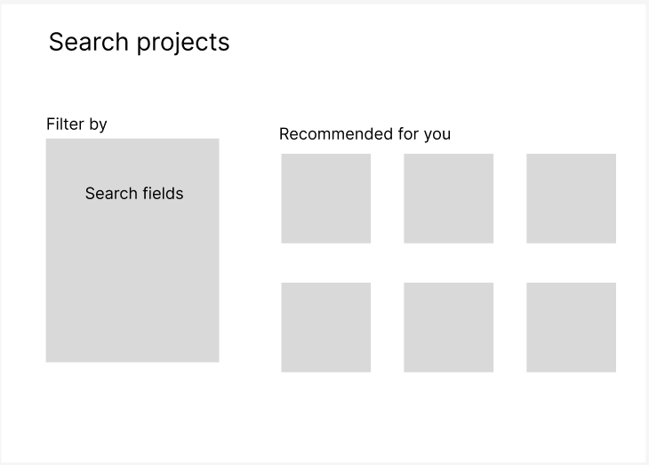

Open Project Details Page:

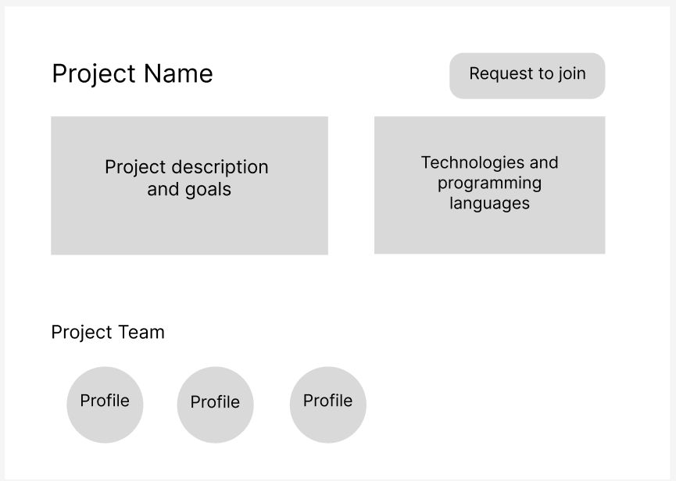

**System workflows:**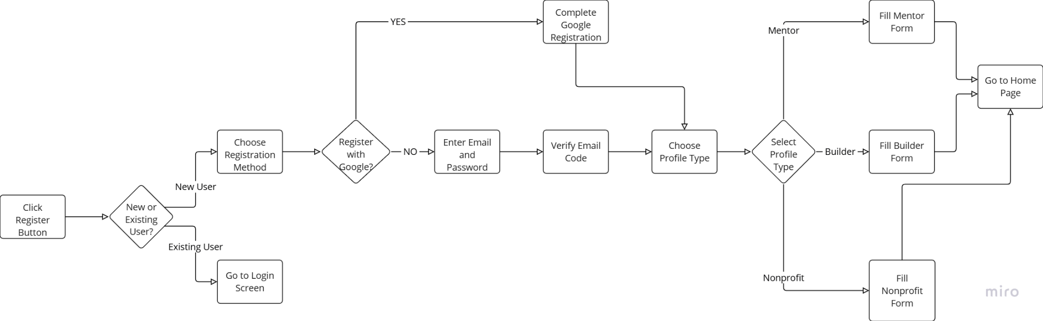

Sign up:



Password recovery:  
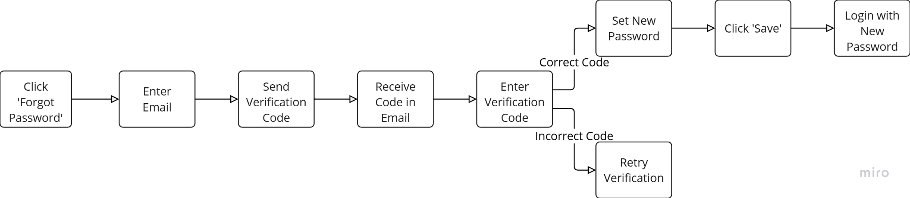



Edit profile details:

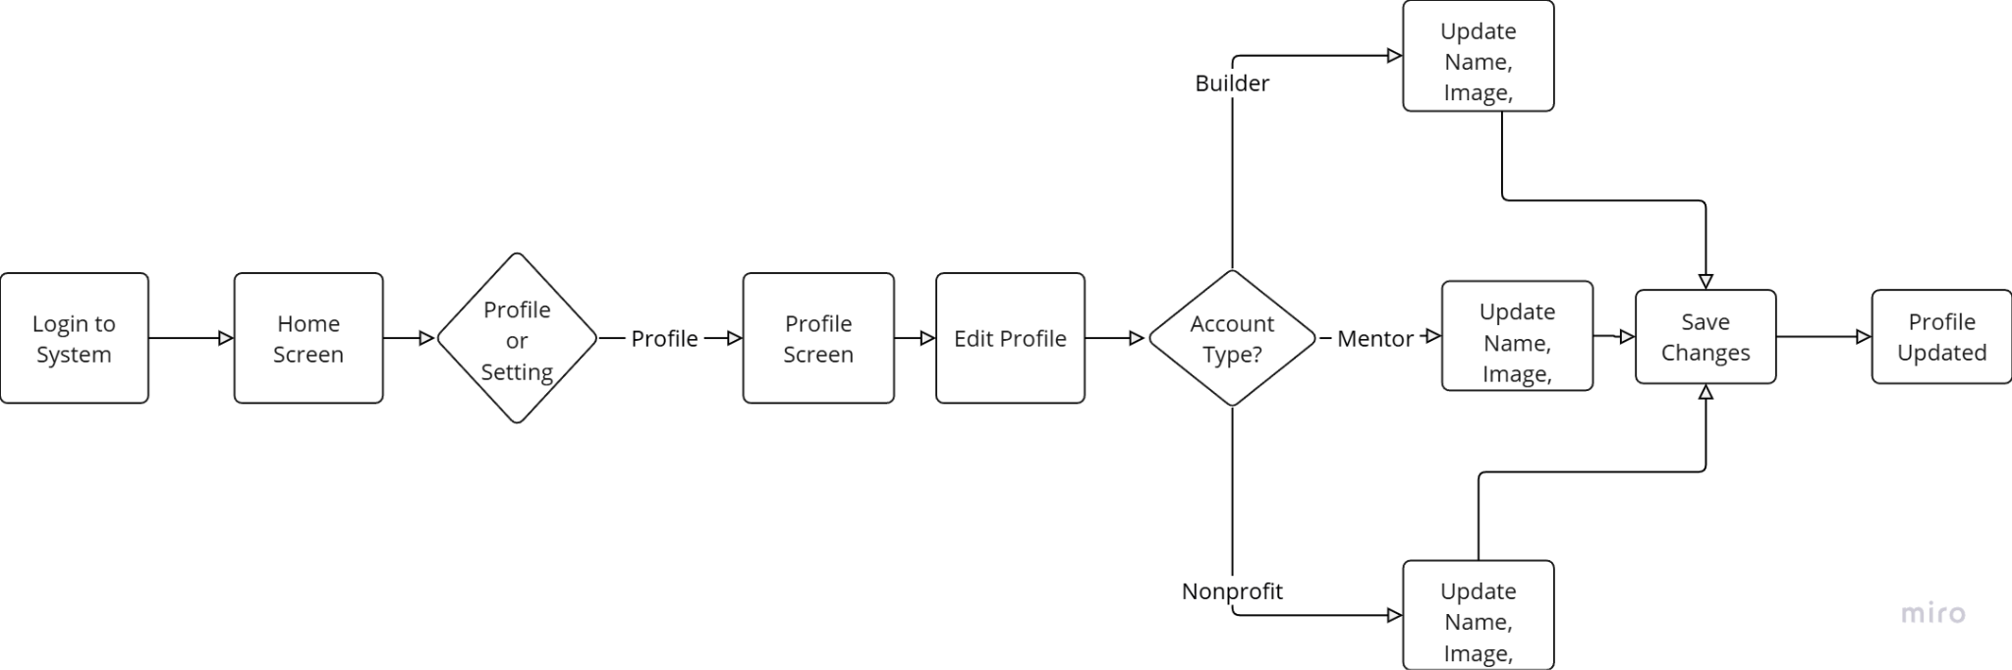



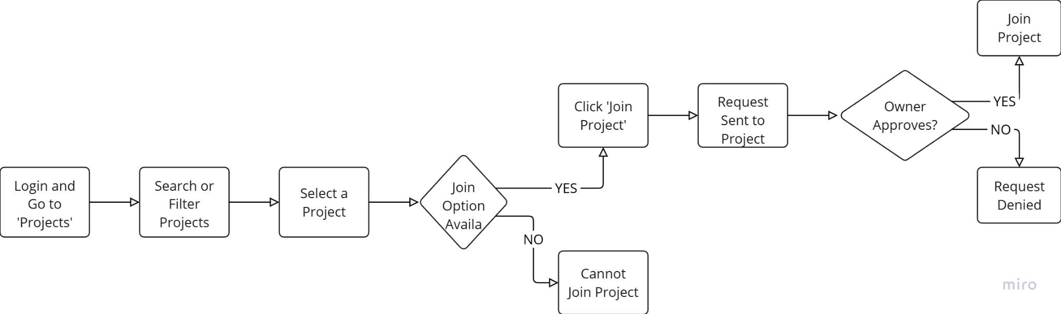

Joining to project:



Opening project:  
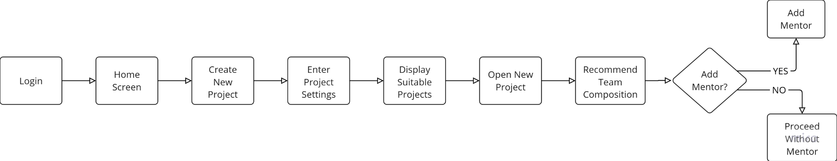

Viewing other users' profiles: